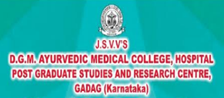
7th International Yoga day-21/06/2021.
Shri. Shivanand vidyavardhaka society's Shri. DanappaMelmalgi Ayurvedic Medical College In Gadag hads conducted the seventh International yoga day on 21st june 20 21.
The department of Swastawruta in Association with NSS wing and sports cell of the college have jointly presented an online virtual Yoga training program for all its institutional faculty student and staff.
The program was inaugurated at 6:30 a.m. by the Chief Guest Shri. Gururaj. Balaganur, ex-president of Gadag-Betigeri Urban Development Authority, the director for board of management of our institution with Jalamruta to the plant. In his presentation he has explained the importance of international yoga day and how the yoga is well proclaimed as a daily regime of health practices, specifically during this pandemic period. He urged all the participants to practice the yoga on every day.
Dr. S. S. HiremathYogacharya and Principle of Shivanand Yoga School in Gadag have trained all the participants virtually with his vast experience and complete explanation. Live virtual presentation of yoga practices has clearly trained all the participants in practicing yoga by self-confidence.
Entire program was well coordinated and planned accordingly and with the schedule by Dr.Budesh Kanaj, NSS officer RGUHS associate professor dept of swasthawritta
As per the program schedule various types of yoga are demonstrated and practiced by yogacharya Dr S S Hiremath.
Different types of yoga for respiratory system, for relaxation of the mind, for stress management and to improve the digestive system were practiced.
Dr. Santosh Belawadi Head, department of Kayachikitsa has presented a poem on *YogadNadeAarogyadaKade*.
Dr U. V. Purad principle of our institution being a President of this function has presented his note on the importance of yoga and health. Specifically during this pandemic covid-19 the importance of yoga means the importance of respiratory system. We have to regularly practice the yoga system and improve our respiratory system and respiratory system both.
The entire program was conducted by NSS officer Dr Budhesh Kanaj.
Dr. Rajani, Department of Kayachikitsa has initiated the program with Dhanvantari prayer and the program was concluded with vote of thanks by Dr Suvarna Nidagundi of department of Rasa Shastra and Bhaishajya Kalpana.
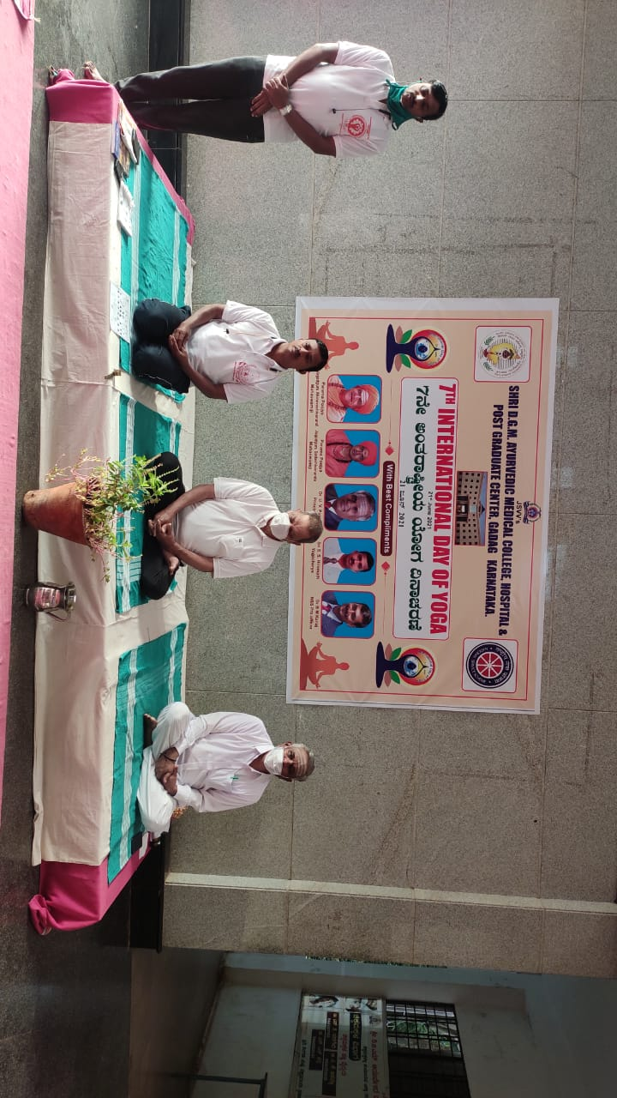
INAUGURATION:By the Chief guest Shri. Gururaj.Balaganur, ex-president of Gadag-Betigeri Urban Development Authority, the director for board of management of our institution with Jalamruta to the plant.
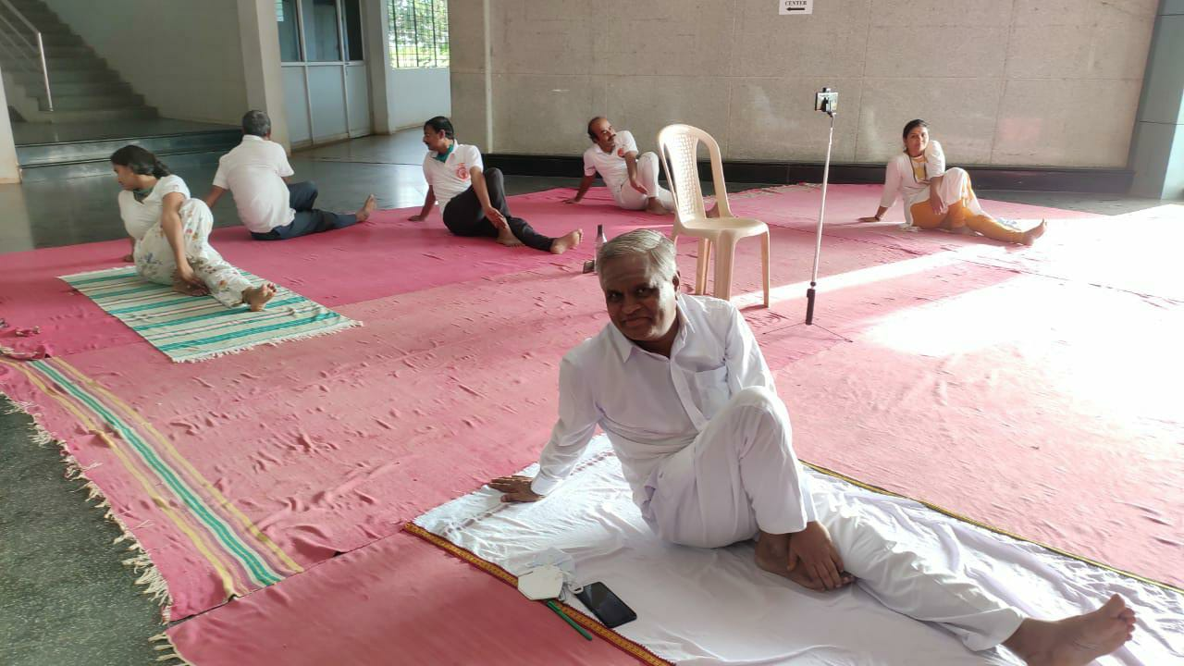
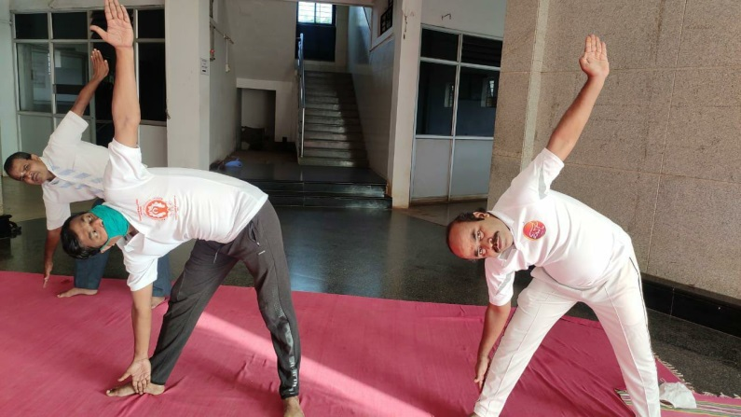
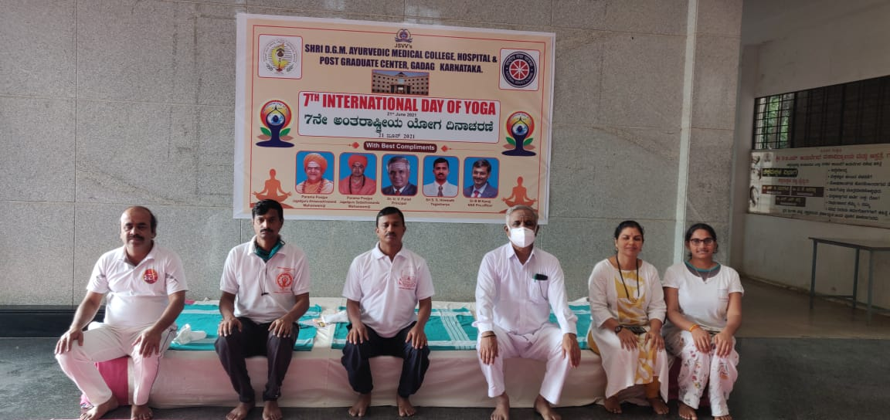
Principal Dr U. V. Purad and faculty performing YOGA

